***CSA1190-OBJECT ORIENTED ANALYSIS AND DESIGN***

***LAB DAY-5***

1. **AGRICULTURE LOAN MANAGEMENT SYSTEM USE CASE DIAGRAM:**

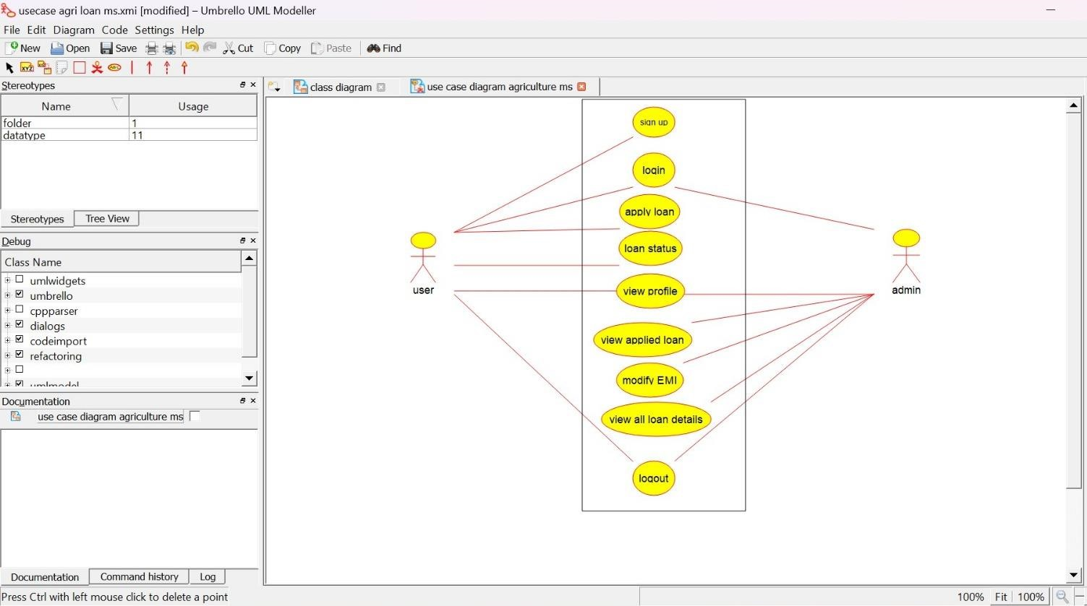

**ACTIVITY DIAGRAM:**

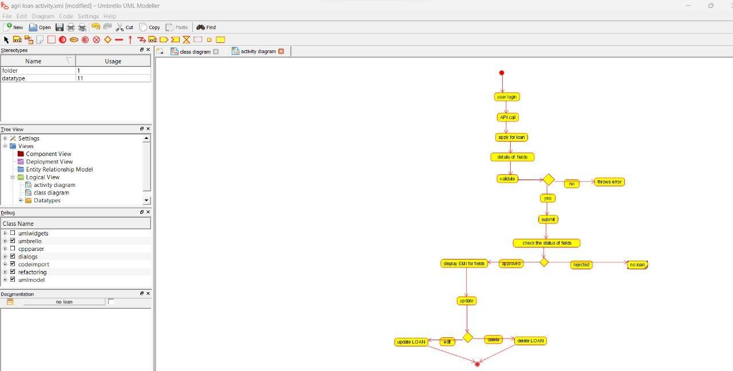

**SEQUENCE DIAGRAM:**

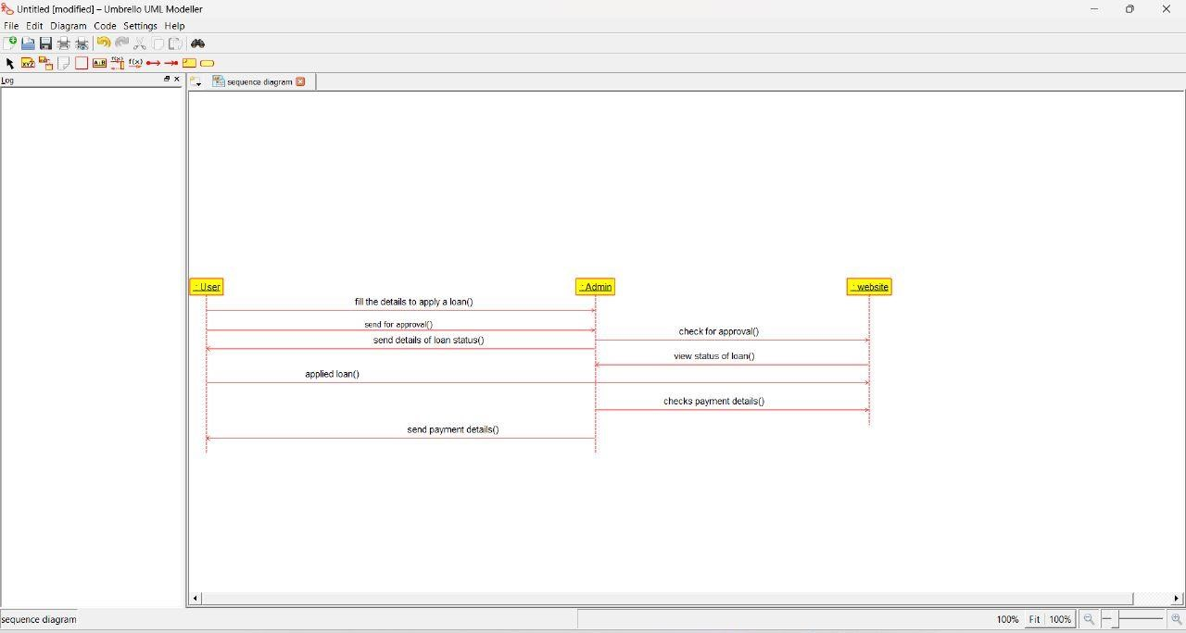

1. **JEWEL LOAN MANAGEMENT SYSTEM USE CASE DIAGRAM:**

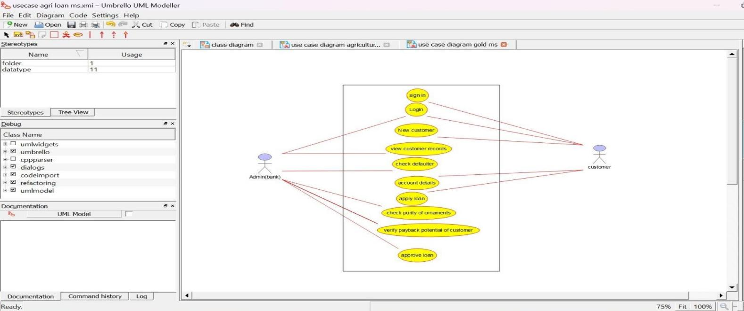

**CLASS DIAGRAM:**

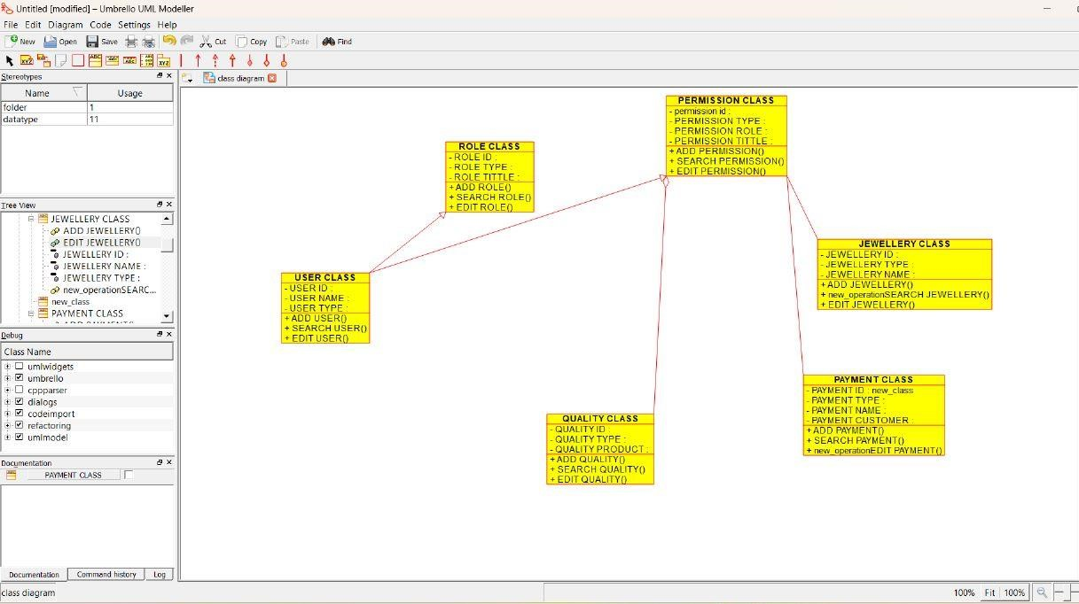

**ACTIVITY DIAGRAM:**

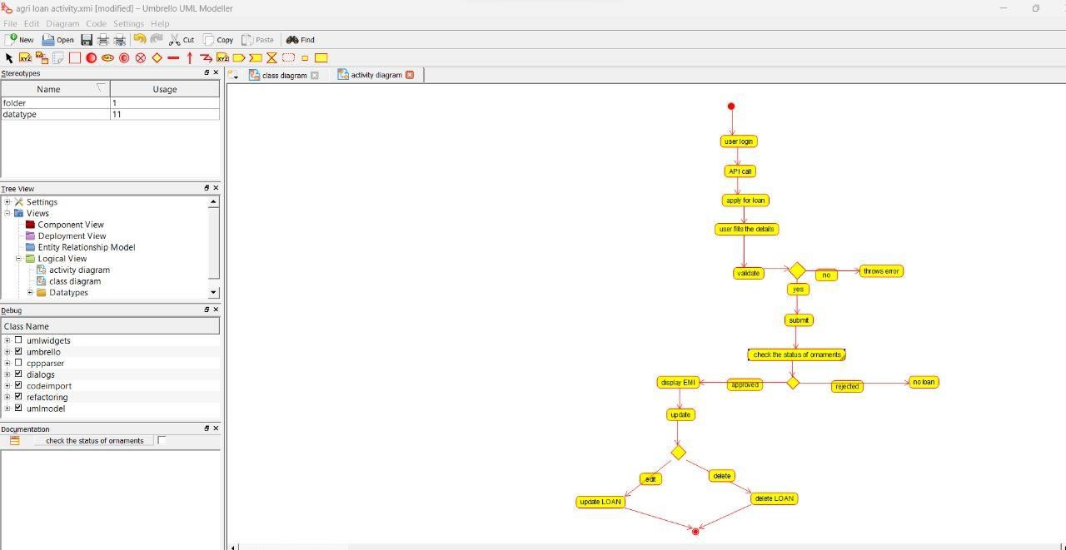

1. **PERSONAL LOAN MANAGEMENT SYSTEM USE CASE DIAGRAM:**

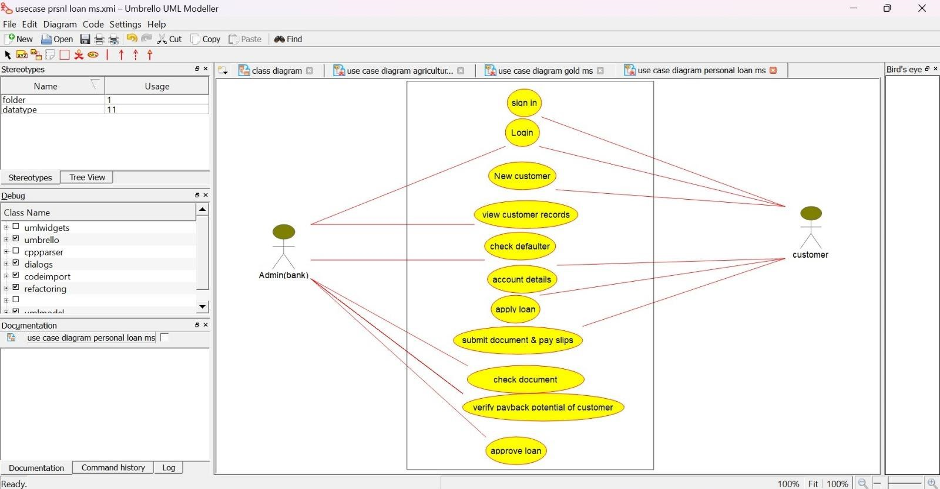

**CLASS DIAGRAM:** 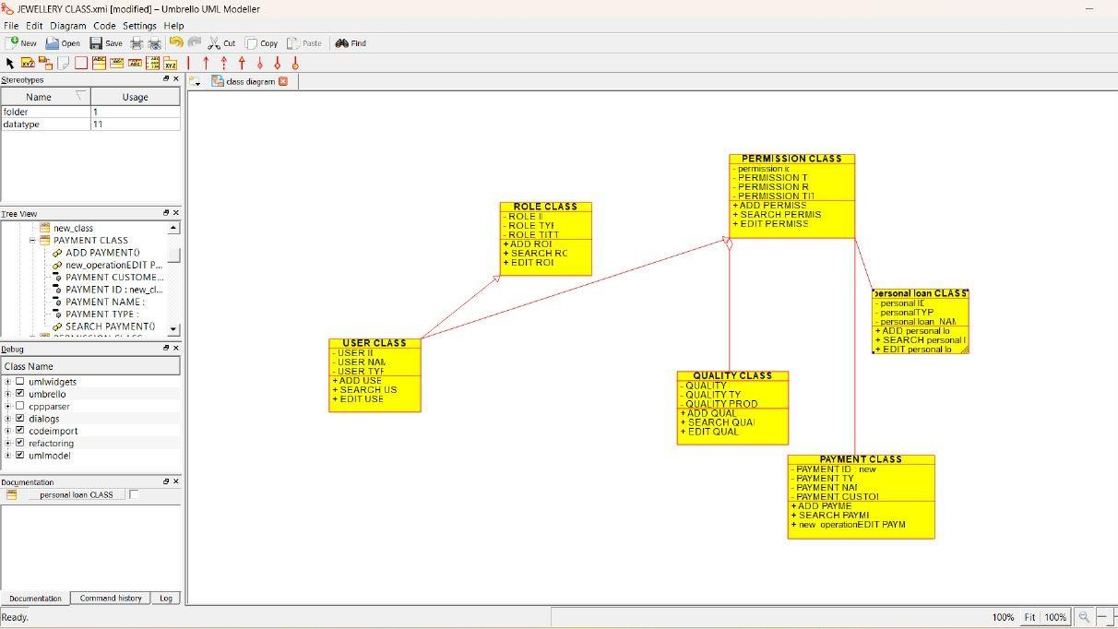

**SEQUENCE DIAGRAM:**

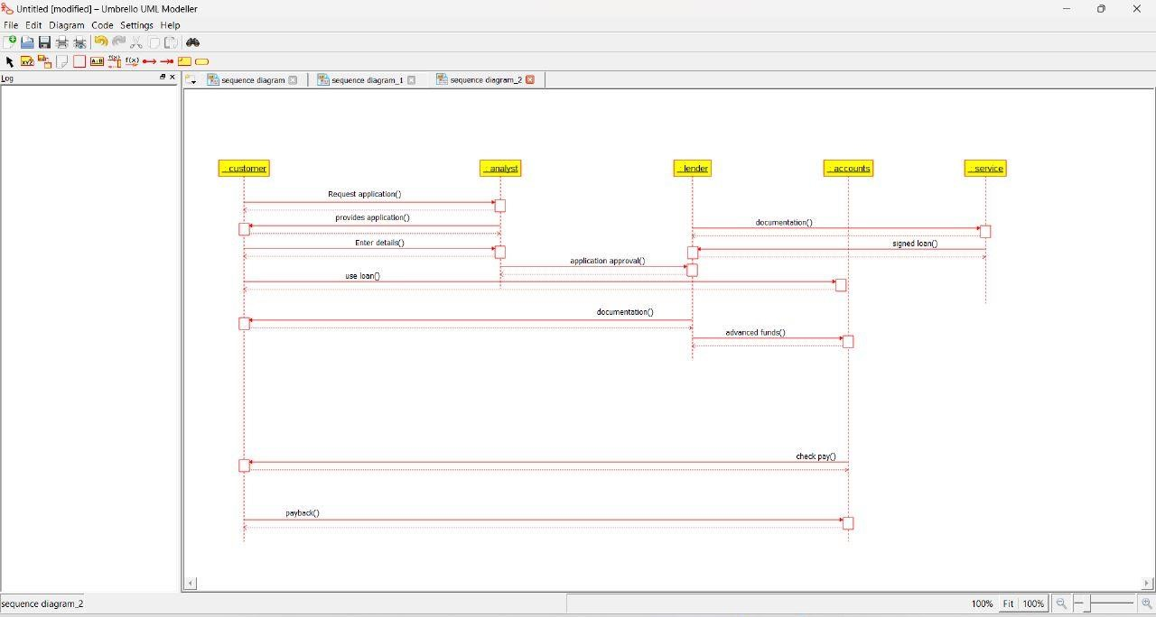

1. **HOME LOAN MANAGEMENT SYSTEM USE CASE DIAGRAM:**

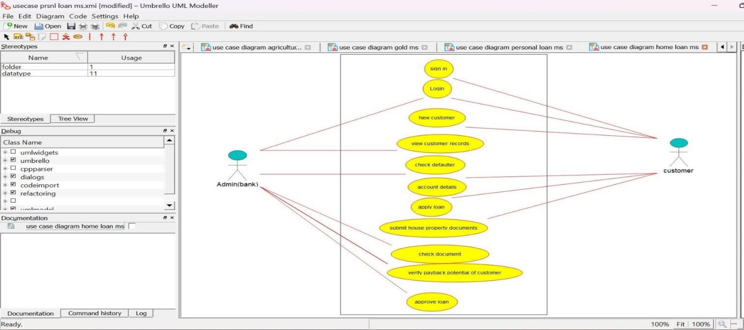

**CLASS DIAGRAM:**

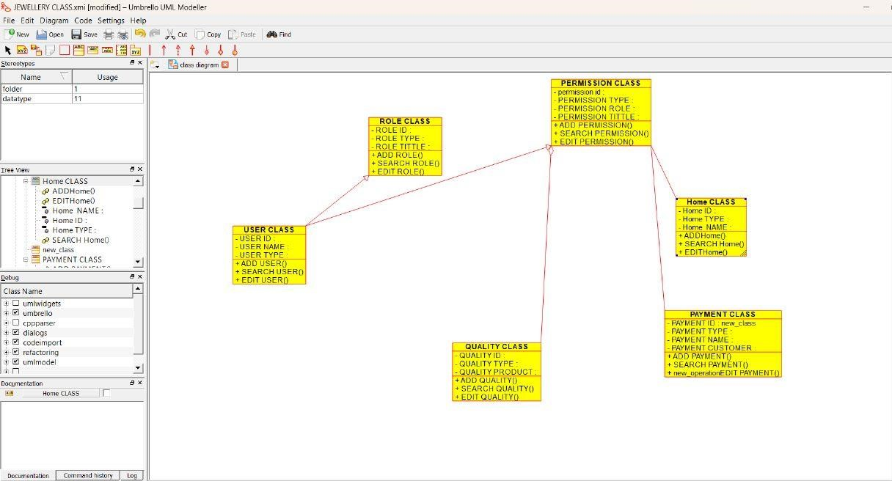

**ACTIVITY DIAGRAM:**

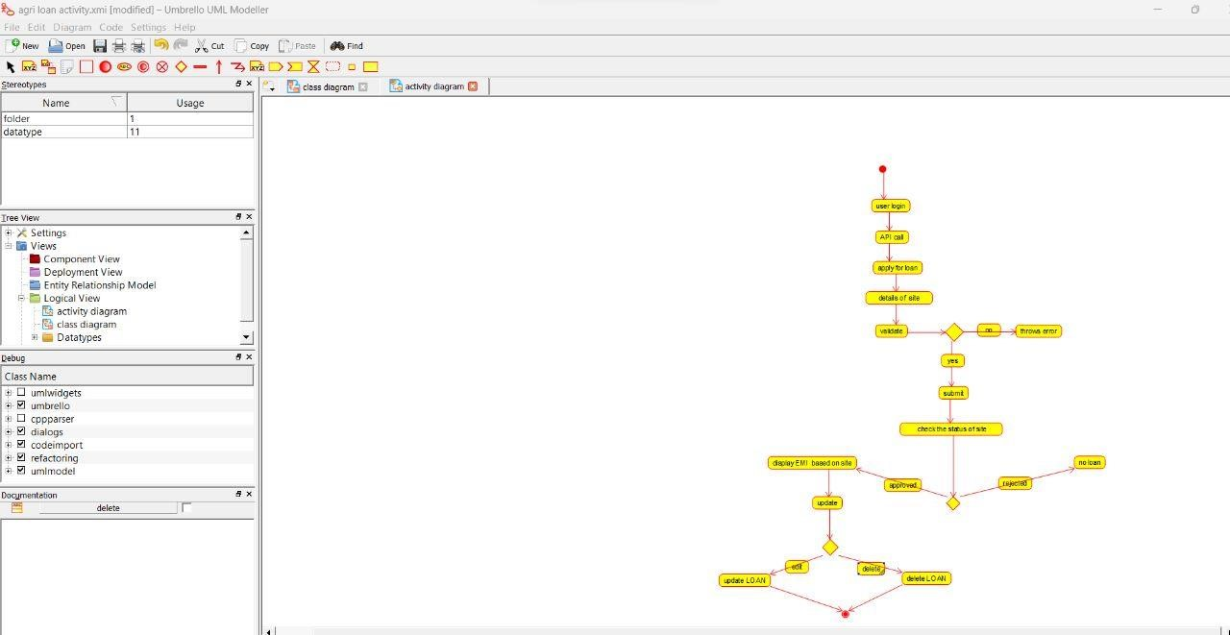

1. **LAND REGISTRATION SYSTEM**

**USE CASE DIAGRAM:**

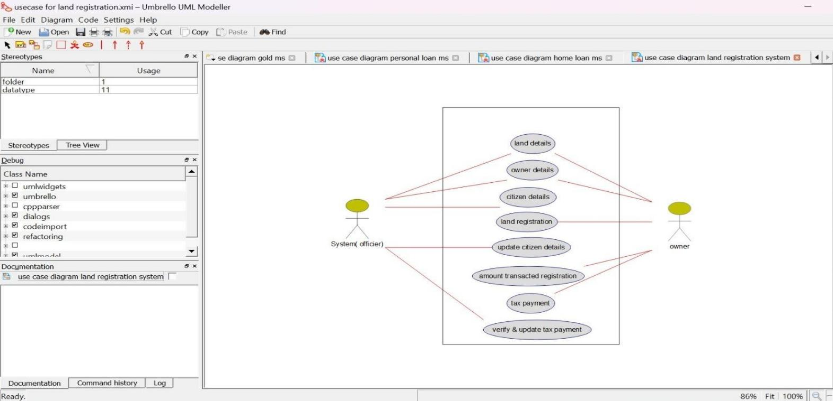

**CLASS DIAGRAM:**

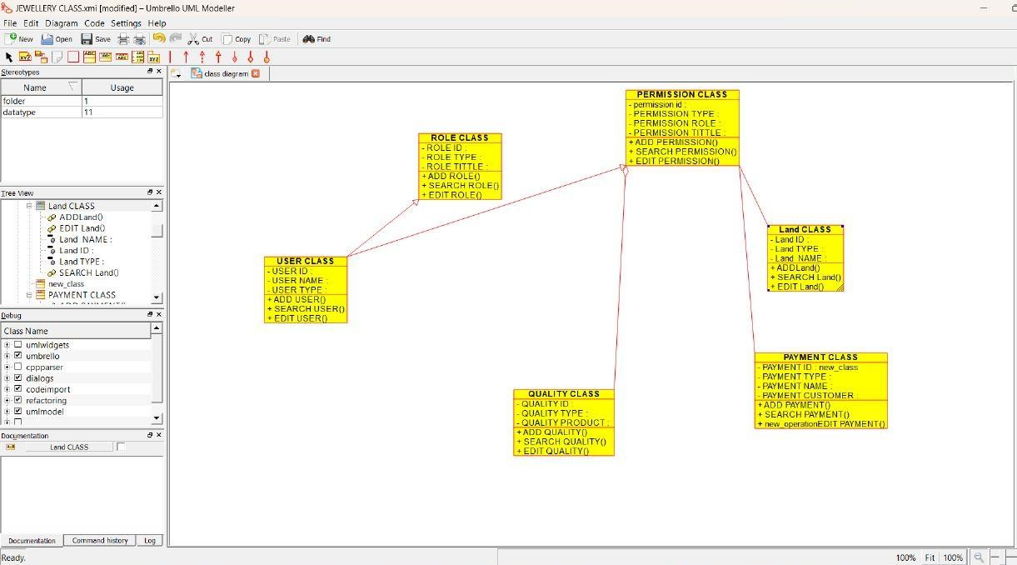

**ACTIVITY DIAGRAM:**

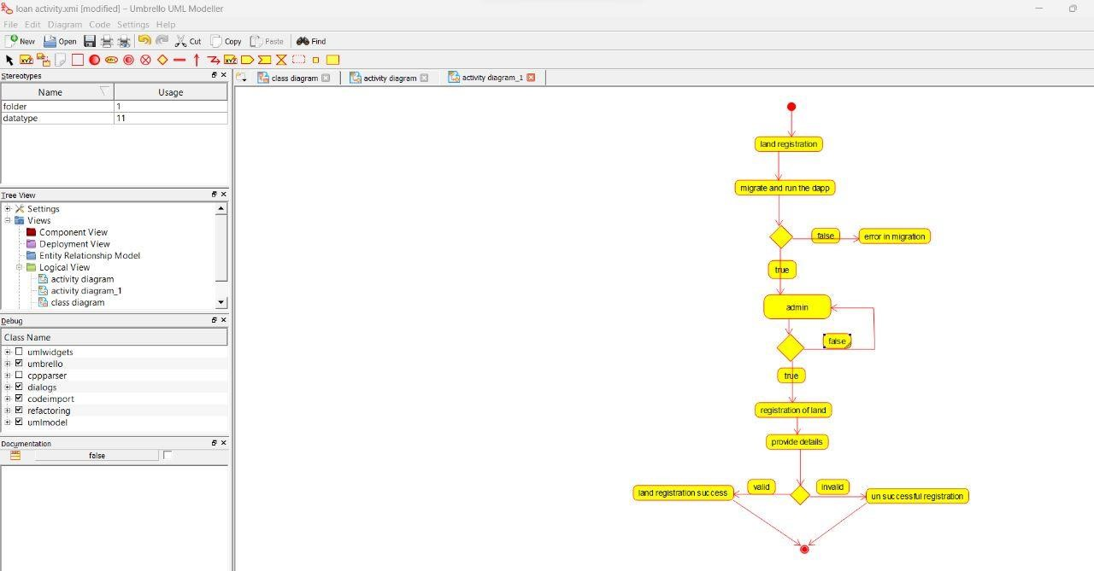

1. **VEHICLE BOOKING SYSTEM USE CASE DIAGRAM:**

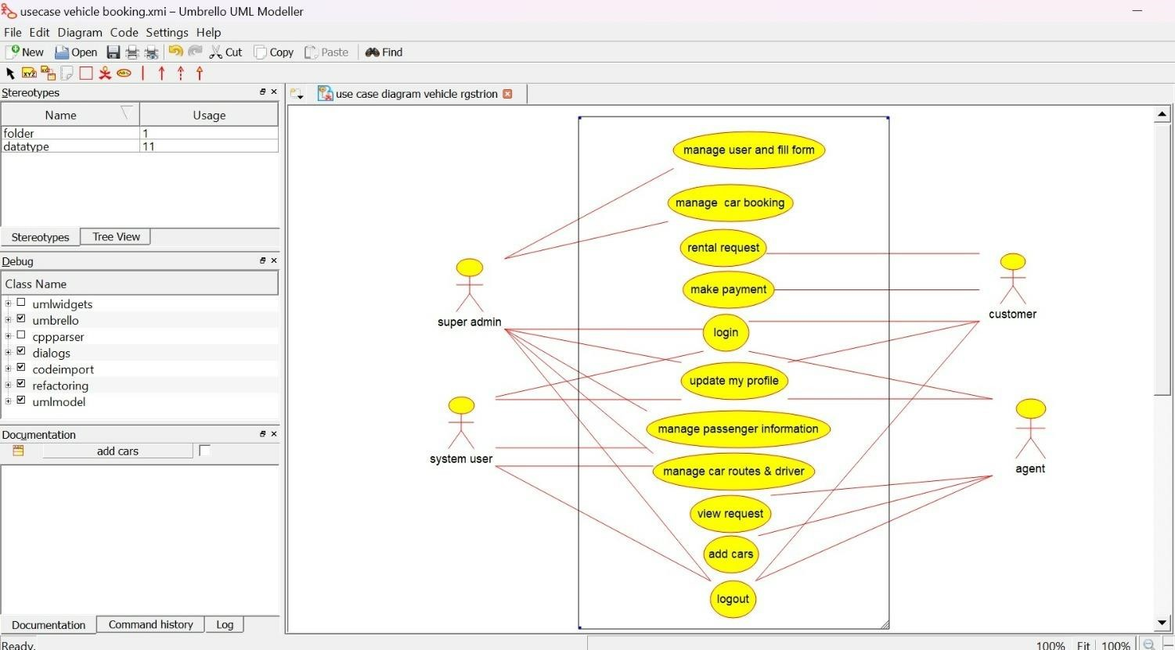

**CLASS DIAGRAM:**

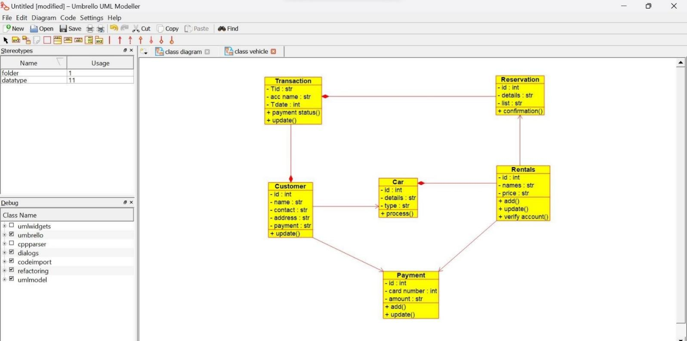

**SEQUENCE DIAGRAM:**

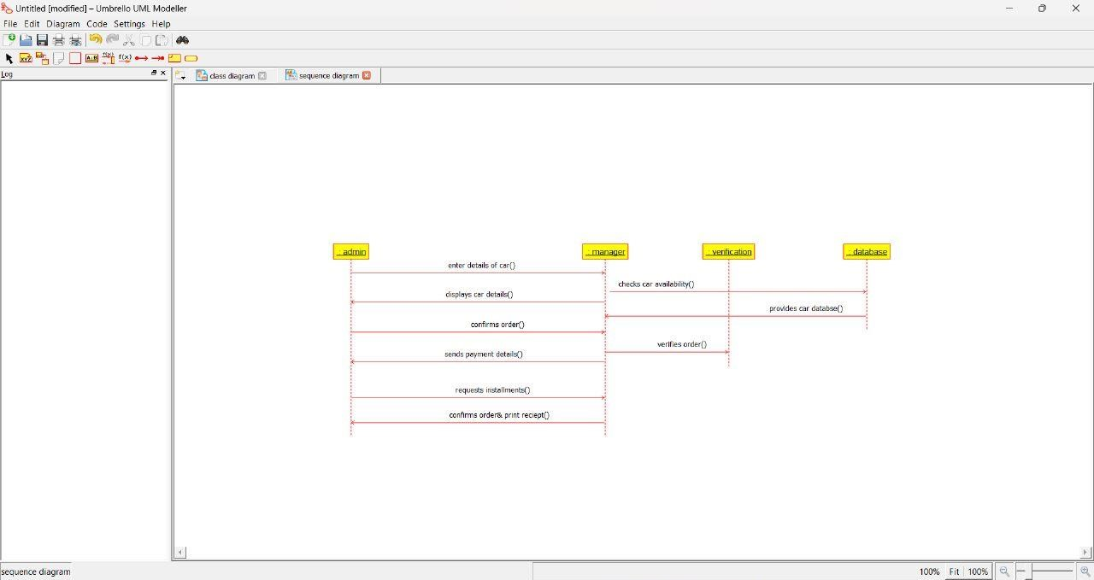

1. **DOCTOR APPOINTMENT SYSTEM USE CASE DIAGRAM:**

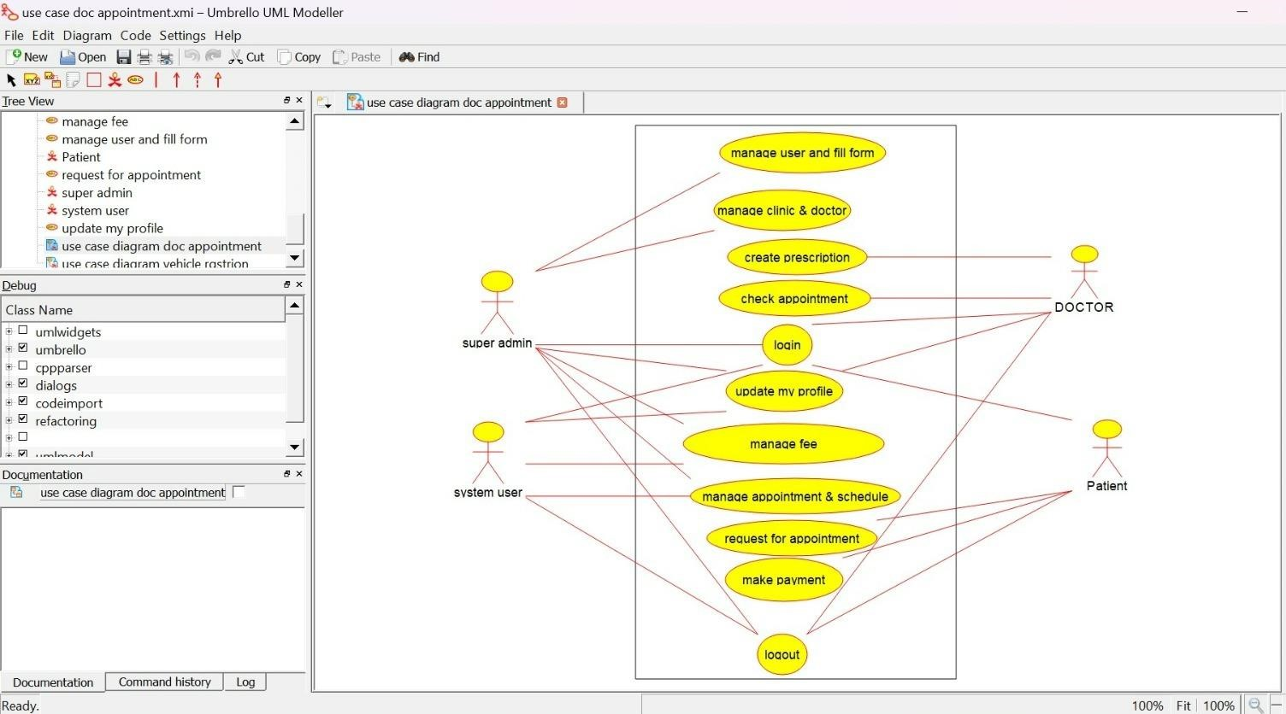

**CLASS DIAGRAM:**

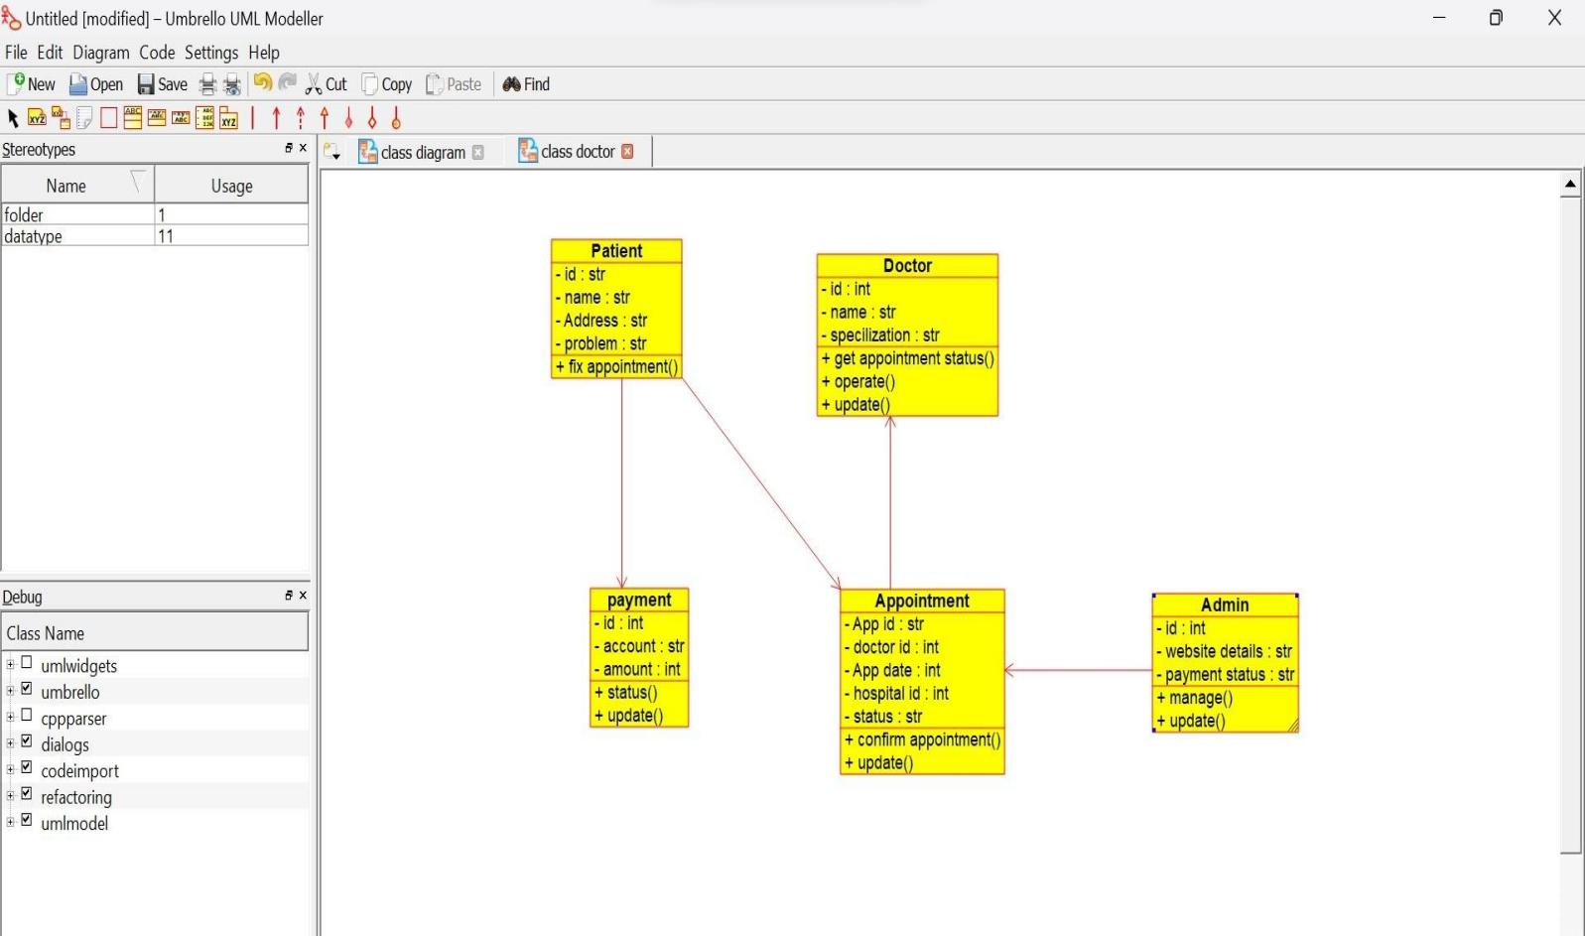

**ACTIVITY DIAGRAM:**

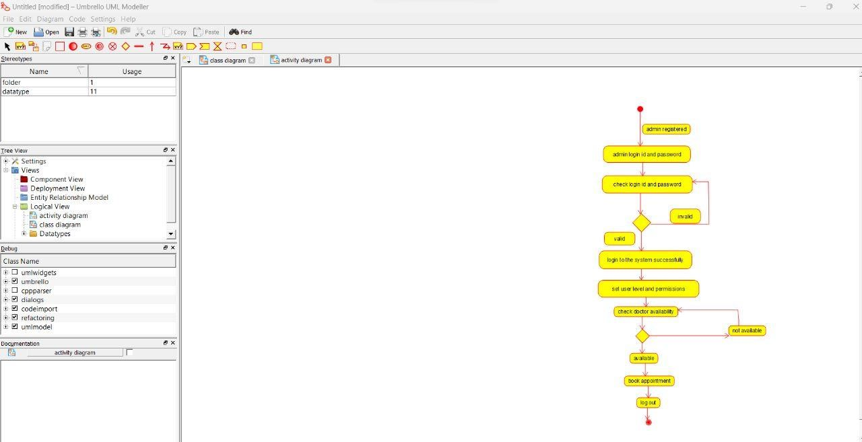

1. **PARLOR RESERVATION SYSTEM USE CASE DIAGRAM:**

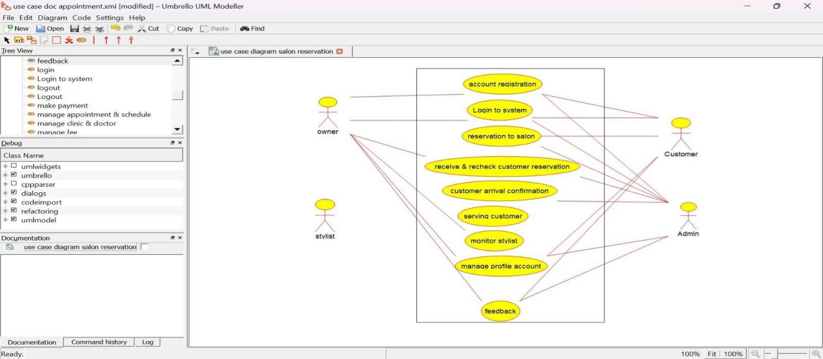

**CLASS DIAGRAM:**

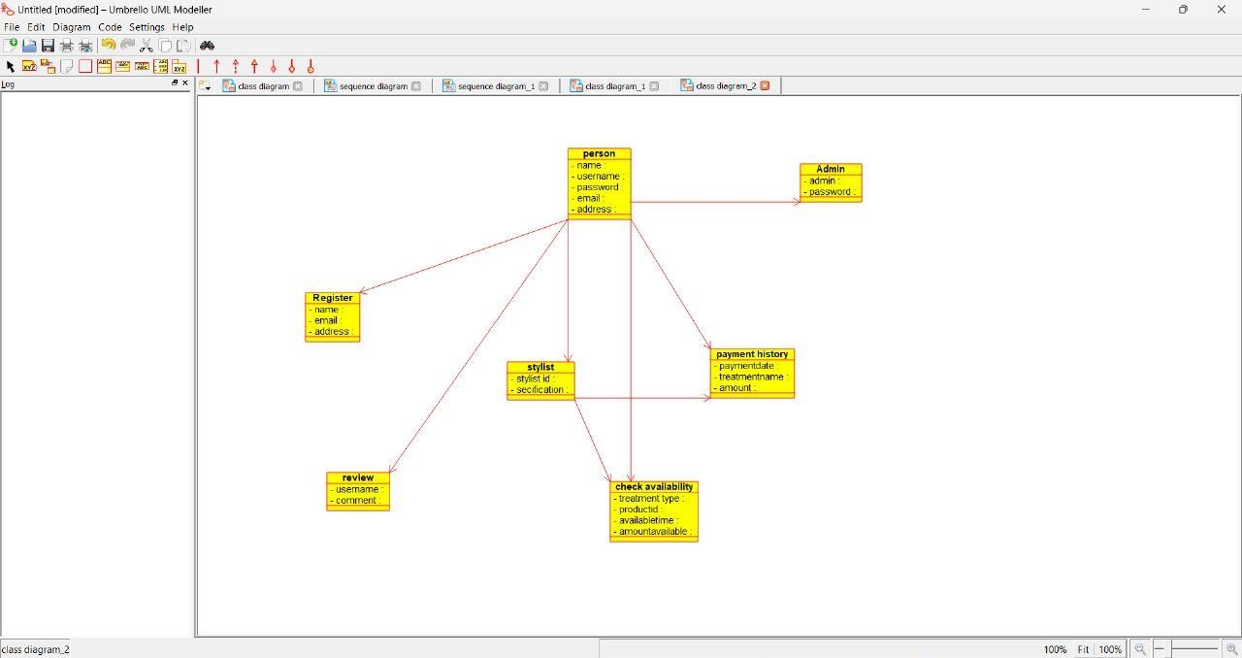

**SEQUENCE DIAGRAM:**

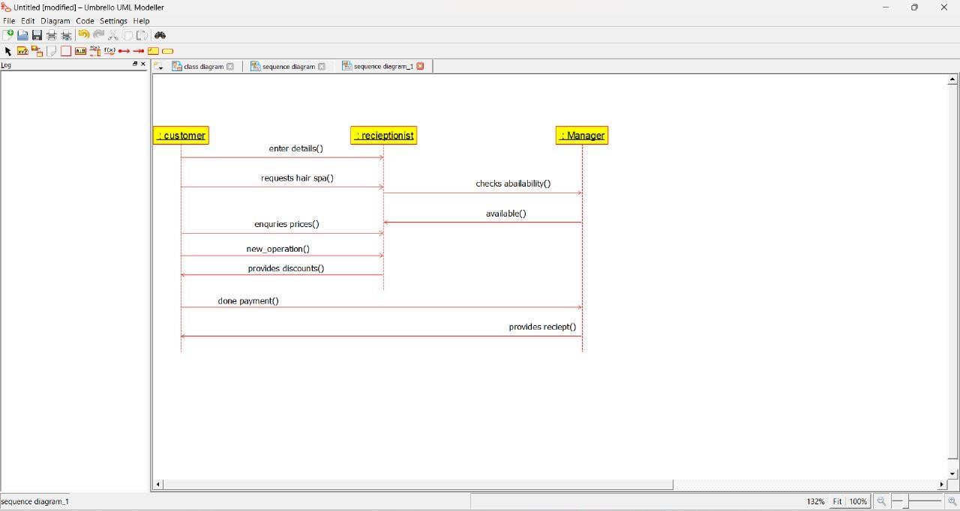

1. **GARDENER BOOKING SYSTEM USE CASE DIAGRAM:**

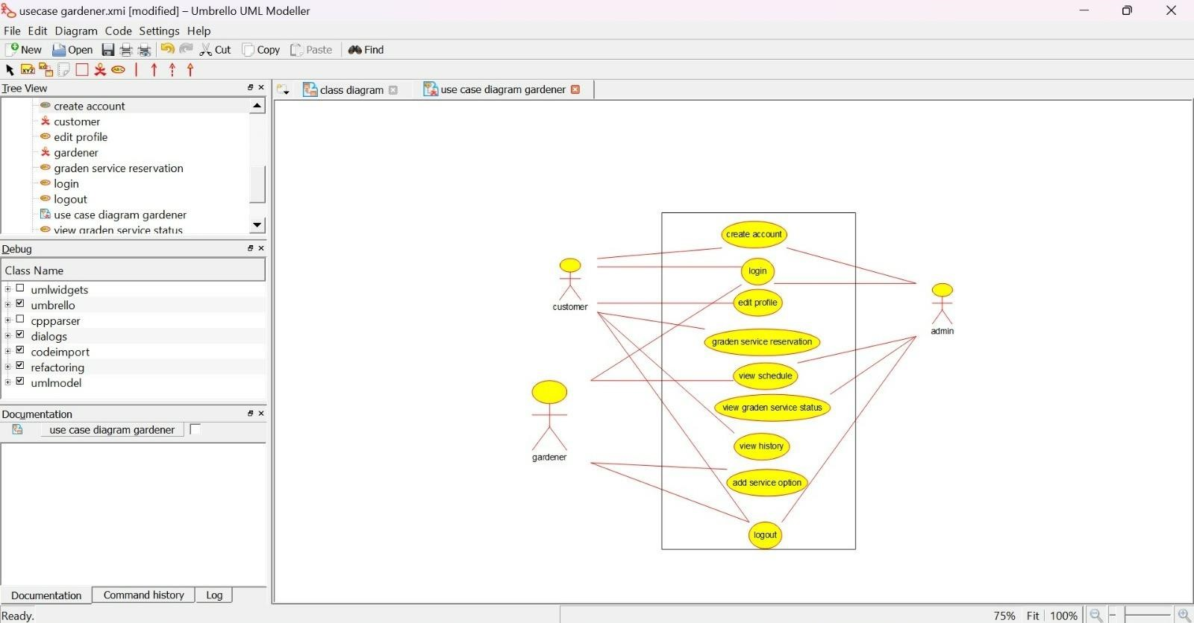

**CLASS DIAGRAM:**

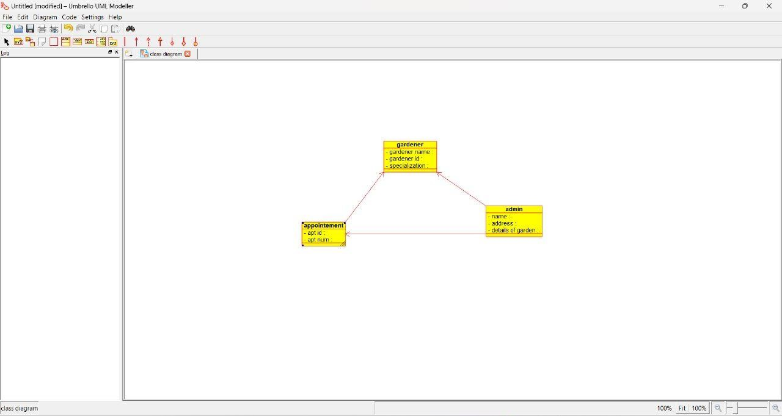

**SEQUENCE DIAGRAM:**

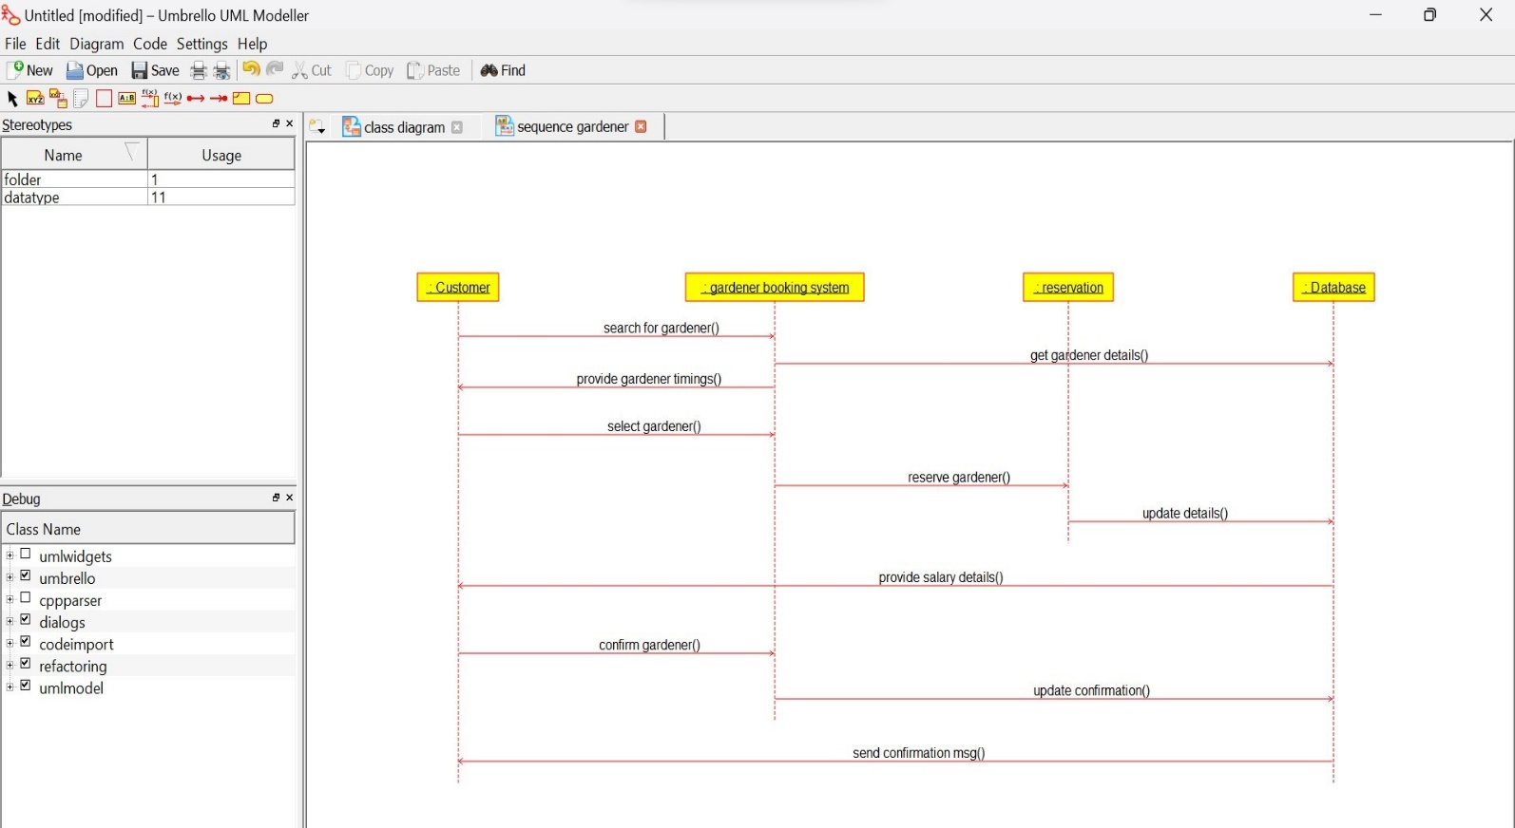

1. **HOME TAX COLLECTION SYSTEM USE CASE DIAGRAM:**

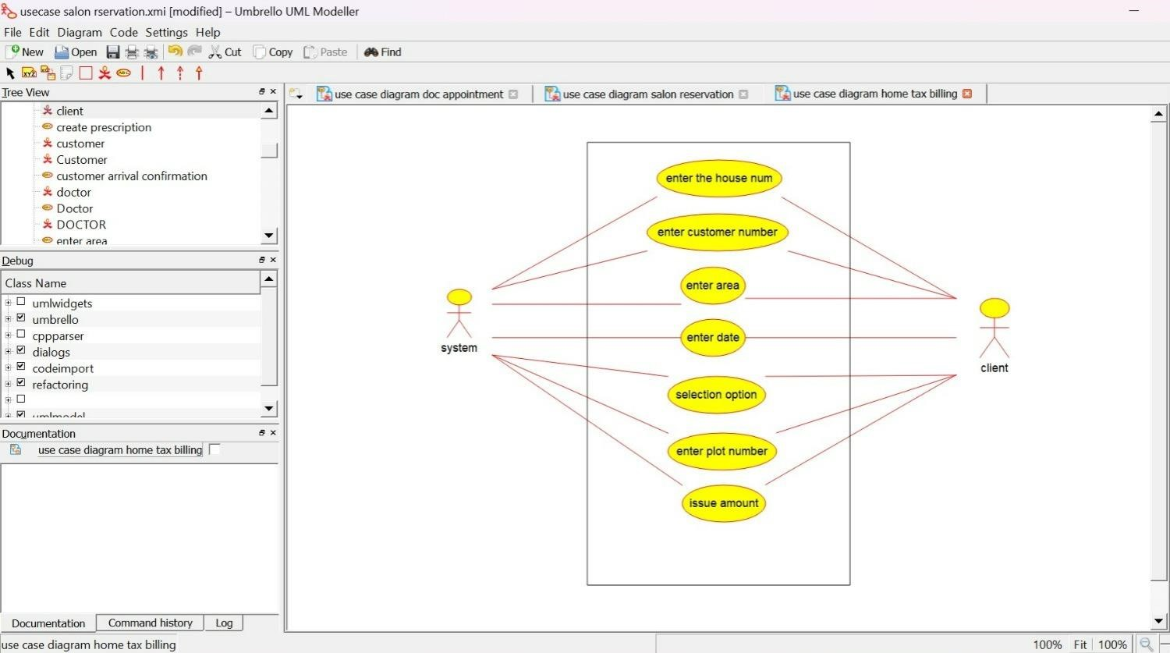

**CLASS DIAGRAM:**

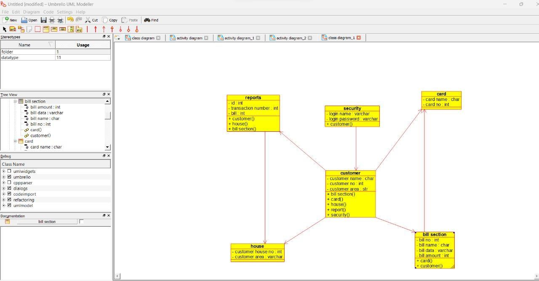

**ACTIVITY DIAGRAM :**

